Thayer Families Association 2016 Reunion

July 1-4, 2016 at West Point, New York

(including tours of West Point, a day trip to New York City, 4th of July celebrations,

learning experiences and much more!)

All you Thayers and your friends are invited to West Point, New York, where we will meet and greet Thayer relatives from across the country, as we focus on General Sylvanus Thayer (June 9, 1785-September 7, 1872), also known as “the Father of West Point”. He was an early superintendent of the United States Military Academy at West Point and an early advocate of engineering education. But he was more than the man who gave engineering to America and the Cadet Honor Code to West Point; he is a hero in our Thayer Family Tree!
We will also focus on two 19th century artists, Abbott Handerson Thayer and Sanford Thayer, who have most certainly passed on their talented genes to the rest of us; and we will have an opportunity to try our hands at our own creations! (Uncork, unwind, and create our own paintings of Trophy Point at West Point!)
On the 240th anniversary of the Declaration of Independence we will also learn about Thayer participation in our War of Independence.

It is important for the planning committee that you register as soon as possible. And it’s important to your bank account that you register for your discounted room at the Thayer Hotel before they are gone! Call 845.446.4731 and ask to be in the Thayer Reunion block!
Tentative Schedule
Friday, July 1, 2016 arrive and check in at the Thayer Hotel
Make your own reservations at the special $106.00 per night (while the special-rate rooms last) when you mention the Thayer Reunion. Ask for the military rate (also $106) if you have military id. ($20.00 extra for a room with two beds) Let reservations know if you have any special room requests. Call today!
The Thayer Hotel, 674 Thayer Rd, West Point, NY 10996 • (800) 247-5047

Please consider bringing something homemade, donated, or solicited for our gift bags!

PLEASE REMEMBER THAT ALL PERSONS, 16 YEARS OF AGE AND OLDER, ENTERING WEST POINT ARE REQUIRED TO BRING GOVERNMENT ISSUED PHOTO ID (DRIVERS LICENSE, PASSPORT, US HIGH SCHOOL ID). No photocopies are accepted.

- Dinner (on your own) is available at the hotel (Friday seafood buffet $36.95 plus tax and service), as well as at a number of more modest restaurants at the bottom of the hill in Highland Falls (ranging from McDonald’s to Mexican to Italian to American). All are just a very short walk from the Hotel. (http://highlandfallsny.org/)
  - General Patton’s Tavern is also in the hotel, is family friendly, and offers typical bar food, such as burgers and wings, at customary prices.

6:30-9:30 p.m. Meet-and-Greet and Show-and-Share in the Pershing Room

- Registration will open at 6:00 p.m. in the Pershing Room
  - Bring any items that you have made or solicited for our gift bags.
  - Check in to get your T-shirt, gift bag, and reunion schedule details.
  - Are you a possible vendor? Let Marilyn Thayer know in advance to arrange for your set-up! (marilynthayer@verizon.net)
  - Make some memories in the photo booth!
- Welcome: Will Thayer, President
- Tell us about YOUR neck of the woods. (Trace on the large map your family’s migration from Braintree to where YOU live NOW!)
- Tammy Thayer: the importance of preserving our Thayer history AND personal stories about her award-winning book A Country Doctor Goes to War, which is about her grandfather Dr. E. A. Thayer
- Bob Thayer: Writing for the Quarterly: Sanford Thayer and Bezaleel Thayer
- Tell us what YOU are doing to preserve our Thayer history! (Do you have history DVDs, scrapbooks, displays, or perhaps a clever way to organize your research?
- Lloyd Thayer: Trace your ancestors from Braintree to where you live NOW!
- Lloyd Thayer: DNA testing
- Jerry Thayer: Thayers in the American Revolution (where they enlisted and a bit about them)

9:30 p.m. Suggestion: Meet at the Zulu rooftop lounge for more conversation!
(see below: just check out that view of the Zulu!)

Below: A view of the Zulu Lounge atop the Thayer Hotel alongside the Hudson River

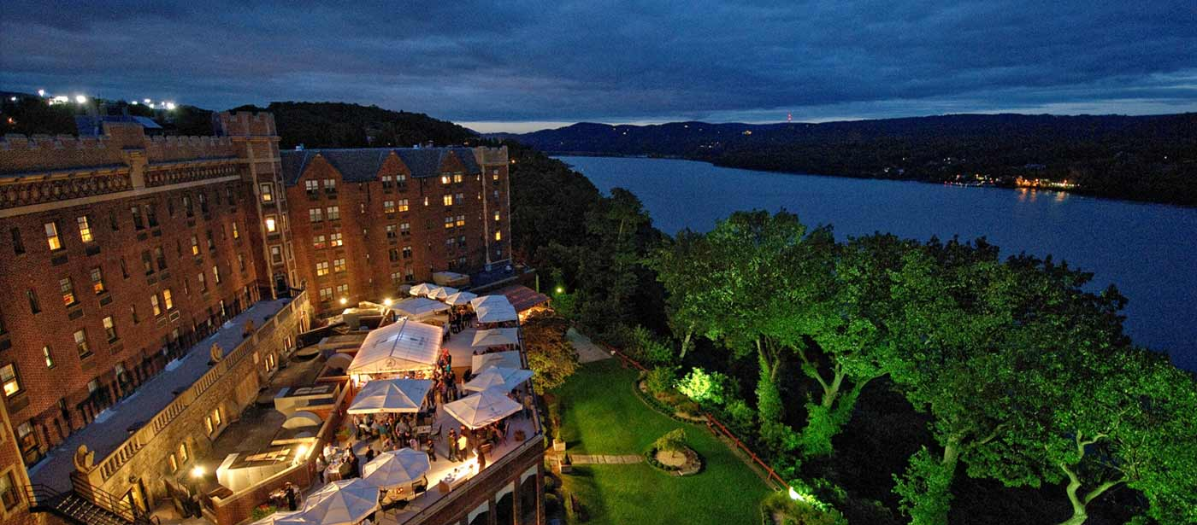

Saturday, July 2, 2016 West Point Day

- Breakfast (on your own) is available in the hotel ($19.95 buffet plus tax and service OR ala carte) OR at the bottom of the hill. Each guest gets free coffee in the room as well as a cup at the Bistro by giving your name and room number. The Bistro also has other beverages, fruits and pastries for sale.

9-12 a.m. Guided Bus and Museum Tour with West Point Tours
($22.00 per person pay in advance with registration)
(* includes bus and museum guides, driver tip, and tips for guides)
Our guide Mary is a treasure-trove of information!

Today we will save tons of money by traveling around the grounds in an air-conditioned school bus. Tomorrow we will travel to NYC in a beautiful motor coach.

Due to security regulations at West Point governing all visitors to the United States Military Academy, we must provide a manifest of all persons participating on our tour, regardless of their age. (Hence the questions on the registration form.

- Wear your TFA Reunion T-shirts today and meet in the lobby at 8:45 a.m.
- Departure from the Thayer Hotel is at 9 a.m. sharp
- Bring along any snacks or beverages you might like on the bus this morning.
- included: group photo stops, Cullum Hall (the refurbished memorial hall for those killed in action), West Point customary stops, as well as the West Point Cemetery (and the grave of Sylvanus Thayer), the Cadet Chapel, and much more!

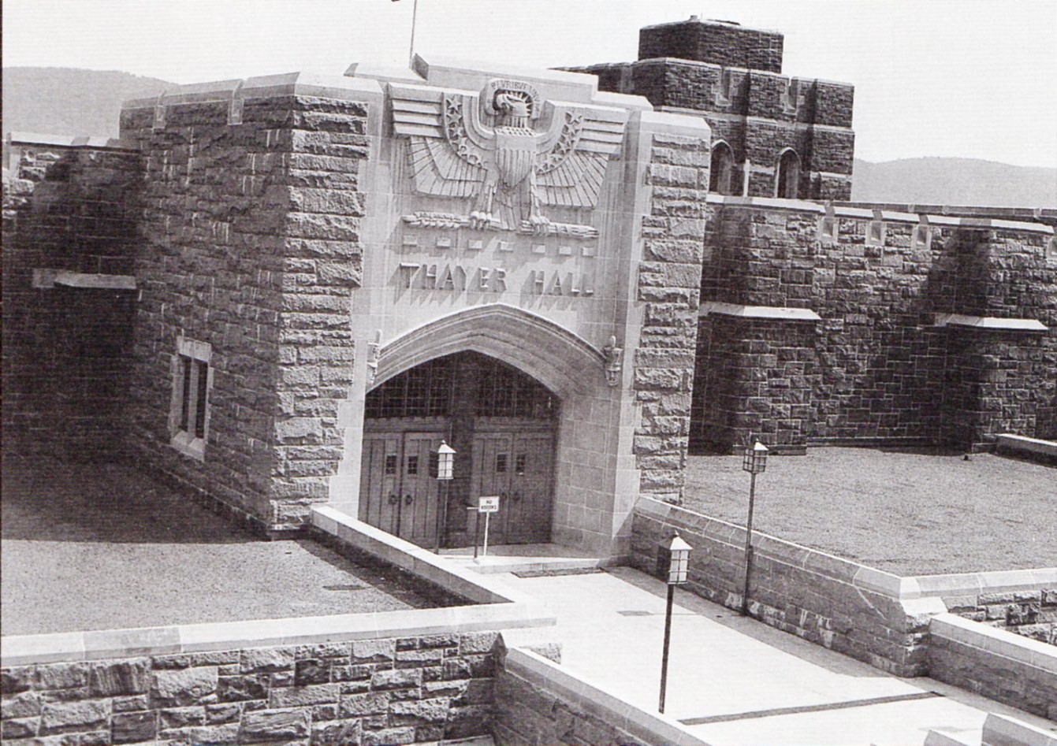

12-1 p.m. Guided Tour of the West Point Museum
- We will divide into three (or more) smaller groups for this tour.

ca. 1:15 – 3:15 p.m. Group Lunch (pay on your own) at Park Restaurant, 451 Main Street, Highland Falls, NY 10928, tel: 845.446.8709 (across the street from the museum) www.parkrest.com
- You are going to LOVE owner Mike Pozo, his home-cooked food offerings, and the creamsicle pie!
- Take a leisurely 5-minute walk back to the Hotel. Anyone who needs a ride should let Marilyn or Bob Thayer know in advance to arrange transportation.
3:30-4:30 p.m. Abbott Handerson Thayer, Artist: A multi-media presentation by Lloyd Thayer (in the Eisenhower Room on the Lobby Floor) http://en.wikipedia.org/wiki/Abbott_Handerson_Thayer self portrait of Abbott H. Thayer

4:30 p.m. Thayer Families Association Business Meeting
(All adults and friends should attend, but only TFA members can vote on business items.) In the Eisenhower Room (Lobby Floor)

7:00 p.m. Dinner in the Thayer Hotel’s McArthur Dining Room
(buffet $50.00 per person, pay in advance, includes gratuities)
Guest speaker: Edna Thayer and TBA
After dinner: Take a walk through the West Point grounds, meet at the Zulu or General Patton’s Tavern, use the fitness room, or rest up for tomorrow!

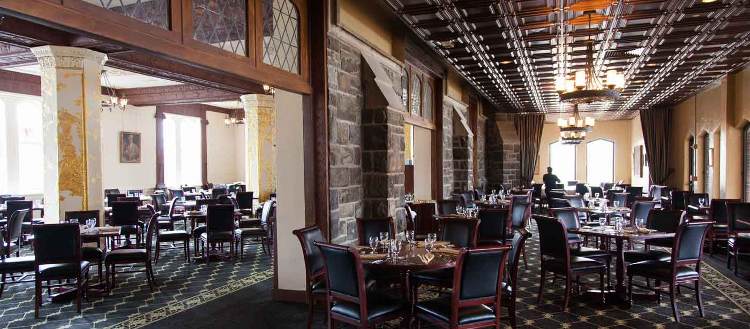

OR BETTER YET:

8:15-10:00 p.m. PAINT NIGHT AT WEST POINT!
You’ve SEEN the million dollar view of the Hudson River Valley from Trophy Point. Now let your Thayer artists’ genes (and an instructor from Wine and Design) guide you in capturing that view in your own souvenir acrylic painting! You will be AMAZED at what you can do! ($35.00 per person, all painting supplies are provided)

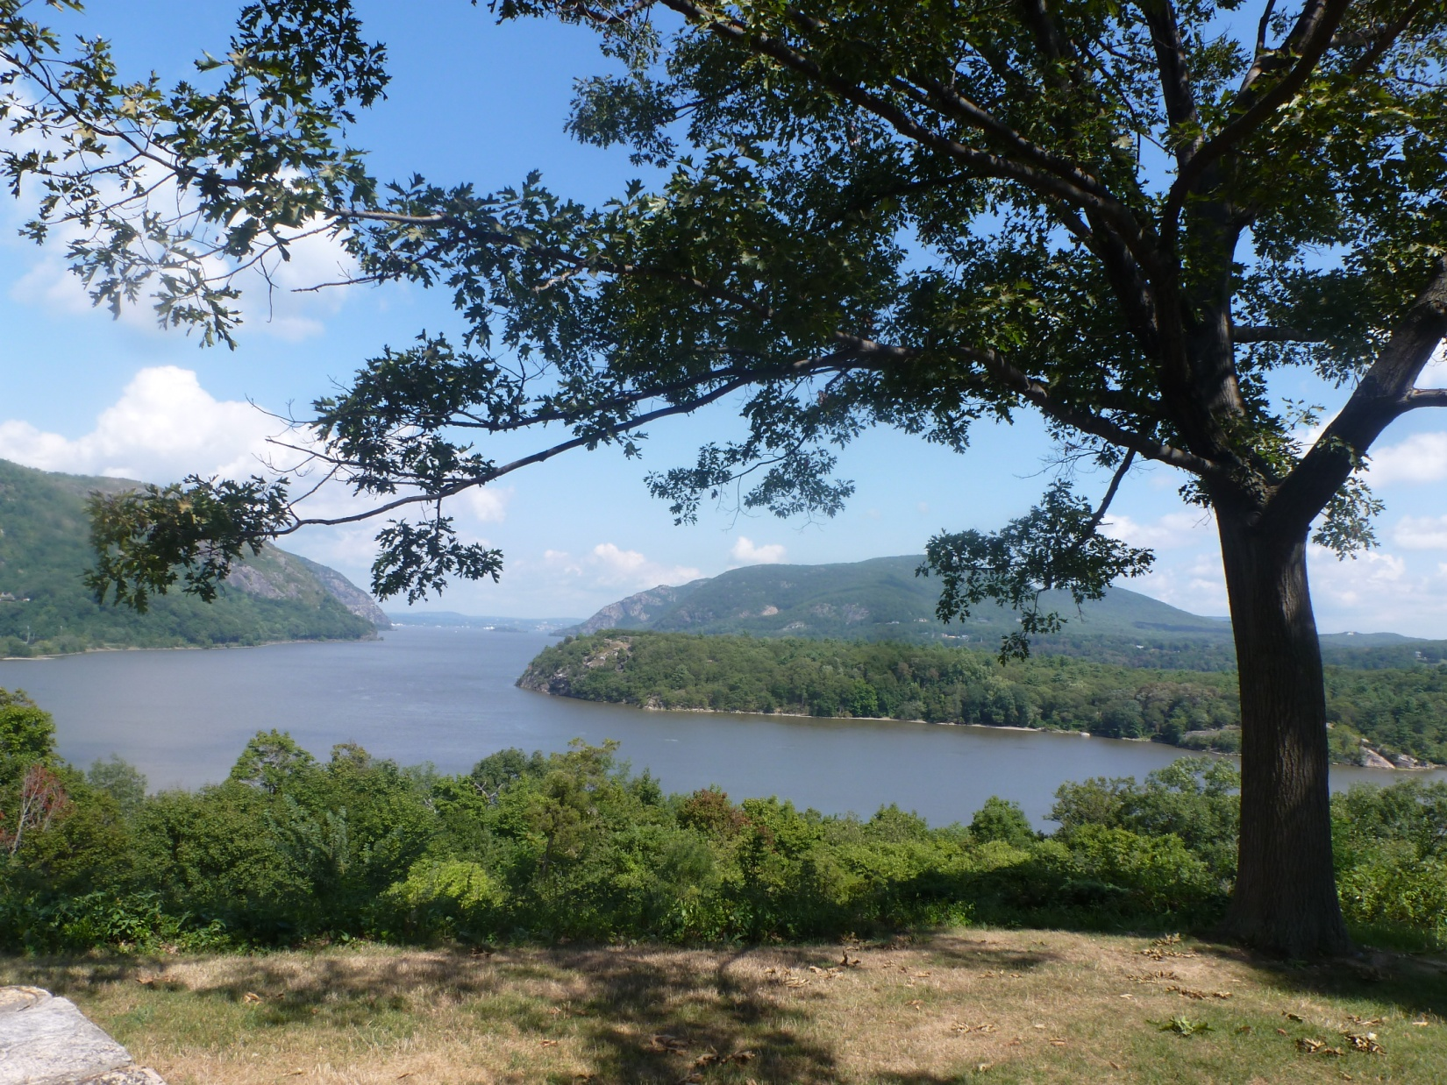

Sunday, July 3, 2016 New York City Day
Not interested in New York City? See other options below
- Breakfast (on your own)
Guided Bus Tour with West Point Tours
Discover “The City That Never Sleeps” -- a historical and cultural center of the world! We’ll take a sightseeing tour to experience some of NYC’s top attractions, including a walk in Central Park, some free time in Manhattan to be awed by the magic of Times Square, the 9/11 Memorial, Wall Street, Little Italy, Chinatown, Harlem, Lincoln Center, Rockefeller Center, and lots more!
- Depart 8 a.m. on Sunday, July 3, from the Thayer Hotel and Tour NYC
- Depart 8 p.m. on Sunday, July 3 from NYC to return to the Thayer Hotel, anticipated arrival before 10 p.m.
- Total transportation charge per person (based on 50 passengers) $35.00 (includes driver gratuity) and step-on guide (based on 50 passengers) $12.00; total due in advance: $47.00. (lunch and dinner on your own)
- Our guide Martha Lanzillotti will spend 6 or more hours with us, showing and telling us about the highlights of the Big Apple. If there is something special YOU would like to see or do, please let us know and we can ask her to include it.

This impressive and poignant 9/11 memorial is known as the Teardrop Memorial. It was a gift to America from the country of Russia and is dedicated "To the Struggle Against World Terrorism."

OTHER OPTIONS FOR SUNDAY: The Hudson Valley is chock full of wonderful sights and sites! If attendance and interest warrant it, we will also plan a bus tour for this area. If not, it is an easy drive for those Thayers who opt out of the NYC Day. Our suggestion: go to Hyde Park where you will find:
Franklin D. Roosevelt Presidential Library and Museum (Hyde Park)
Franklin Delano Roosevelt Home (Hyde Park)
Val-Kill Cottage Eleanor Roosevelt National Historic Site (Hyde Park)
Vanderbilt Mansion National Historic Site (Hyde Park)
Lunch at The Culinary Institute of America (make reservations way in advance!)

** Call ahead to make reservations for the tour times you would like. Tours book quickly even in the off season!
** If you have a national parks pass, yay! Use it in Hyde Park!

OR
Walkway Over the Hudson (Poughkeepsie)
Boscobel House & Gardens (Garrison)
Washington's Headquarters State Historic Site (Newburgh)
OR
Bear Mountain State Park is about seven miles from West Point and for outdoor-lovers, it will be a hot spot. Rent a boat, go fishing, go hiking (the Appalachian Trail goes through the park), visit the small zoo, ride their Merry-go-Round, picnic at Lake Hessian, or just take in the absolutely beautiful views! (Go early because it is the 4th of July weekend and may be very crowded.)

Monday, July 4, 2016 Farewell to some, Celebrate the 4th for those who stay longer!

- Breakfast (on your own)
- If there is enough interest, the Hyde Park trip could be scheduled for this day. Still in the planning: Cruise on the Hudson River? Lunch at Benny Havens? Concert and fireworks? (information still not available) Outlet mall shopping? Washington’s headquarters in Newburgh (about 30 minutes away)?
- More to come when we have more information!

“Yes! We’re Coming to West Point!”

TFA Reunion 2016 Registration Form
Attendee information, as required for the West Point Day Tour manifest: (use back if more space is needed)

____________________________DOB_______________ Type of ID__________ State/Country_____________ Name, Last and First

____________________________DOB_______________ Type of ID__________ State/Country_____________ Name, Last and First

____________________________DOB_______________ Type of ID__________ State/Country_____________ Name, Last and First

____________________________DOB_______________ Type of ID__________ State/Country_____________ Name, Last and First

Mailing address:____________________________________________________________________________

__________________________________________________________________________________________

BEST way to contact you (add your cell for contact information during the reunion): Please PRINT NEATLY!
Tel. number:__________________________ email:________________________________________________
Cell:_________________________________ May we share your info with reunion guests? _____yes ____ no
Number attending: ________ Reunion T-shirt sizes and number of each size (complimentary from TFA):
Youth: Small_____ Medium_____ Large_____
Adult: Small_____ Medium_____ Large_____ XL_____ XXL_____
Please tell us how many to include in the following; and send your payment check accordingly, along with your registration form (made out to Thayer Families Association):
_____ Saturday, July 2, guided tour of West Point @ $22 per person = $______________
_____ Saturday dinner in the Thayer Hotel’s McArthur Room @ $50 per person = $______________
_____New York City bus and tour @ $47 per person (8 am – 10 pm) $______________
Please email marilynthayer@verizon.net or call 315.963.7021 with your questions and suggestions! (call 727.289.8981until April 18!)
Please send checks made out to TFA, along with registration forms AS SOON AS POSSIBLE to:
Judith Young-Thayer, 1006 Old Denbigh Boulevard, Apt. 213, Newport News, VA 23602-2029
Registration DEADLINE is May 30, 2016

